**J526 Yuvasri Ravikumar**

**SQL Assignment**

Ticket Booking System

**Task 1:**

**1.Create the database named "TicketBookingSystem"**

mysql> create database TicketBookingSystem;

mysql> use TicketBookingSystem;

* 1. **2.Write SQL scripts to create the mentioned tables with appropriate data types, constraints, and relationships.**
  + **Venu**
  + **Event**
  + **Customers**
  + **Booking**

1. create table Venu(venue_id int primary key, venue_name varchar(50), address varchar(80));
2. create table Event( event_id int primary key, event_name varchar(80), event_date date, event_time time, venue_id int, total_seats int, available_seats int, ticket_price decimal(10,2), event_type enum('Movie', 'Sports', 'Concert'), booking_id int,

constraint fk_venue_id FOREIGN KEY(venue_id) REFERENCES Venu(venue_id));

1. create table Customer(customer_id int primary key, customer_name varchar(50), email varchar(50), phone_number BigInt);
2. create table Booking(booking_id int primary key, customer_id int, event_id int, num_tickets int, total_cost decimal(10, 2), booking_date date, constraint fk_customer_id FOREIGN KEY(customer_id) REFERENCES Customer(customer_id), constraint fk_event_id FOREIGN KEY(event_id) REFERENCES Event(event_id));

**3.Create an ERD (Entity Relationship Diagram) for the database.**

By using symbols

Oval -> attributes(double oval for multivalued attribute , dashed for derived )

Rectangle -> entity type

Diamond -> relationship

Primary key -> underlined attribute

Foreign key -> dashed underlined attribute

And

Lines to show association between the elements, ERD is drawn to visually view the database.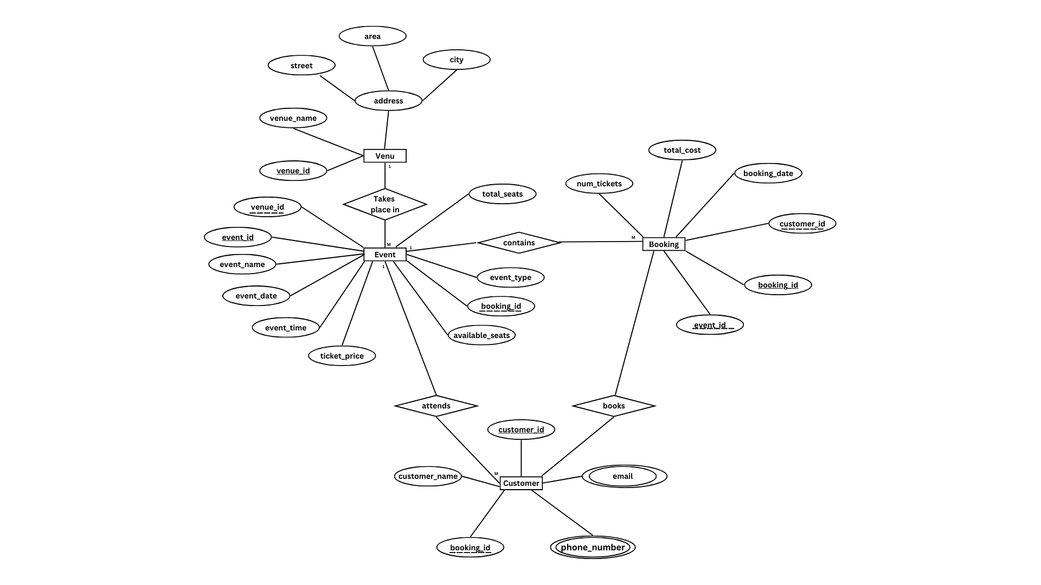

**4.Create appropriate Primary Key and Foreign Key constraints for referential integrity.**

Tables are created using appropriate primary and foreign keys to ensure referential as well as entity integrity.

alter table Customer add booking_id int;

alter table Customer add constraint fk_booking_id FOREIGN KEY (booking_id) REFERENCES Booking(booking_id);

alter table Event add constraint fk_book_id FOREIGN KEY(booking_id) REFERENCES Booking (booking_id);

**Tasks 2:**

**Select, Where, Between, AND, LIKE:**

**1. Write a SQL query to insert at least 10 sample records into each table.**

**Venu Table:**

Insert into Venu (venue_id, venue_name, address)

Values (11, 'Pine Forest Stadium', '123 Main Street, Ooty, TN'),

(22, 'Oaks And Fun', '4546 , Kalpana St, Kodaikanal, TN'),

(33, 'Girly Garden', '7589, Kamraj, Tirunelveli, TN'),

(44, 'Golden Beach', '1044, Tower Street, Trichy, TN'),

(55, 'Garden Hall', '202, Greenery area, Kanyakumari, TN'),

(66, 'Serene View', '75, Vetri Nagar, Chennai, TN'),

(77, 'Moon and Fun', '44 , TVK Nagar, Chennai, TN'),

(88, 'Candle light', '505,Perambur, Ooty, TN'),

(99, 'Juicy Chemistry', '696, Royal Nagar, Vellore, TN'),

(111, 'Ballet Arena', '77, Pine Glory, Kodaikanal, TN');

**Event Table:**

insert into Event (event_id, event_name, event_date, event_time, venue_id, total_seats, available_seats, ticket_price, event_type)

values

(1, 'Avatar', '2025-03-15', '18:30:00', 11, 200, 150, 1500.99, 'Movie'),

(2, 'BTS Concert', '2025-03-20', '22:00:00', 22, 500, 450, 2000.99, 'Concert'),

(3, 'World Cup Cricket', '2025-02-10', '19:30:00', 33, 300, 100, 1000.00, 'Sports'),

(4, 'Vijay Antony Concert', '2025-02-05', '21:00:00', 55, 150, 120, 3000.00, 'Concert'),

(5, 'Soccer World Cup', '2025-01-20', '18:00:00', 44, 800, 750, 1750.00, 'Sports'),

(6, 'Leo', '2025-01-22', '17:00:00', 66, 250, 200, 2440.50, 'Movie'),

(7, 'Anirudh Concert', '2025-03-18', '20:30:00', 77, 600, 550, 1220.00, 'Concert'),

(8, 'Tennis women', '2025-03-12', '16:00:00', 88, 400, 350,1180.00, 'Sports'),

(9, 'Conjuring', '2025-02-04', '22:00:00', 99, 300, 280, 1080.00, 'Movie'),

(10, 'Lana Del Rey', '2025-01-12', '22:30:00', 111, 200, 180, 4500.00, 'Concert');

**Booking Table:**

insert into Booking (booking_id, event_id, num_tickets, total_cost, booking_date)

values

(101, 1, 20, 2500.98, '2025-03-15'),

(102, 2, 40, 3990.96, '2025-03-22'),

(103, 3, 30, 4050.00, '2025-02-10'),

(104, 4, 10, 3000.00, '2025-02-05'),

(105, 5, 50, 1500.00, '2025-01-20'),

(106, 6, 20, 3100.00, '2025-01-22'),

(107, 7, 30, 3600.00, '2025-03-18'),

(108, 8, 20, 1600.00, '2025-03-12'),

(109, 9, 40, 4502.00, '2025-02-04'),

(110, 10, 20, 1090.00, '2025-01-12');

**Customer Table:**

insert into Customer (customer_id, customer_name, email, phone_number, booking_id)

values

(22, 'Kalpana P', 'kalpana@gmail.com', 1234567890, 101),

(44, 'Stella T', 'stella@gmail.com', 1111111101, 102),

(75, 'Lolita Y', 'lolita@gmail.com', 2222222212, 103),

(46, 'Samantha S', 'Samantha@yahoo.com', 3333333123, 104),

(93, 'Harry P', 'harry@yahoo.com', 5678901234, 105),

(94, 'Vanilla T', 'vanilla@yahoo.com', 7777000000, 106),

(37, 'Geetha A', 'geetha@gmail.com', 1234567890, 107),

(68, 'Mary G', 'maryy@gmail.com', 8888880000, 108),

(47, 'Jaya', 'jaya@gmail.com', 9012345678, 109),

(90, 'Lalitha', 'lalitha@gmail.com', 1234500000, 110);

**To update booking_id in Event Table;**

update Event set booking_id=101 where event_id=1;

update Event set booking_id=102 where event_id=2;

update Event set booking_id=103 where event_id=3;

update Event set booking_id=104 where event_id=4;

update Event set booking_id=105 where event_id=5;

update Event set booking_id=106 where event_id=6;

update Event set booking_id=107 where event_id=7;

update Event set booking_id=108 where event_id=8;

update Event set booking_id=109 where event_id=9;

update Event set booking_id=110 where event_id=10;

**To update booking_id in Customer Table:**

update Customer set booking_id=101 where customer_id=22;

update Customer set booking_id=102 where customer_id=44;

update Customer set booking_id=103 where customer_id=75;

update Customer set booking_id=104 where customer_id=46;

update Customer set booking_id=105 where customer_id=93;

update Customer set booking_id=106 where customer_id=94;

update Customer set booking_id=107 where customer_id=37;

update Customer set booking_id=108 where customer_id=68;

update Customer set booking_id=109 where customer_id=47;

update Customer set booking_id=110 where customer_id=90;

**To update customer_id in Booking Table:**

update Booking set customer_id=22 where booking_id = 101;

update Booking set customer_id=44 where booking_id = 102;

update Booking set customer_id=75 where booking_id = 103;

update Booking set customer_id=46 where booking_id = 104;

update Booking set customer_id=93 where booking_id = 105;

update Booking set customer_id=94 where booking_id = 106;

update Booking set customer_id=37 where booking_id = 107;

update Booking set customer_id=68 where booking_id = 108;

update Booking set customer_id=47 where booking_id = 109;

update Booking set customer_id=90 where booking_id = 110

**2. Write a SQL query to list all Events.**

mysql> select * from Event;

**3. Write a SQL query to select events with available tickets.**

mysql> select * from Event where available_seats > 0;

**4. Write a SQL query to select events name partial match with ‘cup’.**

mysql> select event_id,event_name from Event where event_name like '%cup%' or event_name like

'%Cup%';

**5. Write a SQL query to select events with ticket price range is between 1000 to 2500.**

mysql> select event_id,event_name from Event where ticket_price between 1000.00 and 2500.00;

**6. Write a SQL query to retrieve events with dates falling within a specific range.**

mysql> select event_id,event_name,event_date from Event where event_date between '2025-01-21' and '2025-03-10';

**7. Write a SQL query to retrieve events with available tickets that also have "Concert" in their name.**

mysql> select event_id,event_name from Event where available_seats > 0 and event_name like '%Concert%';

**8. Write a SQL query to retrieve users in batches of 5, starting from the 6th user.**

mysql> select customer_id,customer_name from Customer limit 5 offset 5;

**9. Write a SQL query to retrieve bookings details contains booked no of ticket more than 4.**

mysql> select * from Booking where num_tickets > 4;

**10. Write a SQL query to retrieve customer information whose phone number end with ‘000’**

select * from Customer where cast(phone_number as char) like '%000';

**11. Write a SQL query to retrieve the events in order whose seat capacity more than 15000.**

mysql> select event_id,event_name from Event where total_seats > 15000 order by total_seats;

**12. Write a SQL query to select events name not start with ‘x’, ‘y’, ‘z’**

mysql> select event_name from Event where event_name not like 'x%' and event_name not like 'y%' and event_name not like 'z%';

**Tasks 3:**

**Aggregate functions, Having, Order By, Group By and Joins:**

**1. Write a SQL query to List Events and Their Average Ticket Prices.**

mysql> select event_id,event_name,avg(ticket_price) from Event group by event_id,event_name;

**2. Write a SQL query to Calculate the Total Revenue Generated by Events.**

mysql> select e.event_id,e.event_name, sum(b.total_cost) as total_revenue from Event e join Booking b ON e.event_id = b.event_id group by event_id,event_name;

**3. Write a SQL query to find the event with the highest ticket sales.**

mysql> select e.event_id,event_name,sum(num_tickets) as tickets_sold from Event e join Booking b where e.event_id = b.event_id group by event_id,event_name order by tickets_sold desc limit 1;

**4. Write a SQL query to Calculate the Total Number of Tickets Sold for Each Event.**

mysql> select e.event_id,event_name,sum(num_tickets) as tickets_sold from Event e join Booking b on e.booking_id = b.booking_id group by event_id,event_name;

**5. Write a SQL query to Find Events with No Ticket Sales.**

mysql> select event_id,event_name from Event where not event_id in (select distinct event_id from Booking);

**6. Write a SQL query to Find the User Who Has Booked the Most Tickets.**

mysql> select c.customer_id, customer_name, sum(num_tickets) as tickets_booked from Customer c join Booking b on c.booking_id = b.booking_id group by c.customer_id, customer_name order by tickets_booked desc limit 1;

**7. Write a SQL query to List Events and the total number of tickets sold for each month.**

mysql> select e.event_id, event_name,MONTH(event_date) as month,sum(num_tickets) as total_tickets from Event e join Booking b on e.event_id= b.event_id group by e.event_id, event_name, MONTH(event_date);

**8. Write a SQL query to calculate the average Ticket Price for Events in Each Venue.**

mysql> select event_id,venue_name,v.venue_id,avg(ticket_price) as average_ticket_price from Event e join Venu v on v.venue_id = e.venue_id group by venue_name, event_id;

**9. Write a SQL query to calculate the total Number of Tickets Sold for Each Event Type.**

mysql> select event_type,sum(num_tickets) as tickets_sold from Event e join Booking b on b.booking_id = e.booking_id group by event_type;

**10. Write a SQL query to calculate the total Revenue Generated by Events in Each Year.**

mysql> select year(event_date) as Year,sum(total_cost) as total_revenue from Event e join Booking b on e.booking_id = b.booking_id group by year(event_date);

**11. Write a SQL query to list users who have booked tickets for multiple events.**

mysql> select c.customer_id,customer_name, count(distinct event_id) as events_count from Booking b inner join Customer c on c.customer_id = b.customer_id group by c.customer_id,customer_name having events_count > 1;

**12. Write a SQL query to calculate the Total Revenue Generated by Events for Each User.**

mysql> select c.customer_id,customer_name,sum(total_cost)as total_revenue from Customer c join Booking b on c.customer_id = b.customer_id group by c.customer_id, customer_name;

**13. Write a SQL query to calculate the Average Ticket Price for Events in Each Category and Venue.**

mysql> select event_type,v.venue_id, venue_name,avg(ticket_price) as average_ticket_price from Venu v join Event e on v.venue_id=e.venue_id group by event_type,v.venue_id,venue_name;

**14. Write a SQL query to list Users and the Total Number of Tickets They've Purchased in the Last 30 Days.**

mysql> select booking_date, c.customer_id,customer_name ,sum(num_tickets)as total_tickets from Customer c join Booking b on c.customer_id = b.customer_id where booking_date >= curdate() - INTERVAL 30 day group by booking_date, c.customer_id, customer_name;

**Tasks 4:**

**Subquery and its types**

**1. Calculate the Average Ticket Price for Events in Each Venue Using a Subquery**

mysql> select v.venue_id,venue_name,(select avg(ticket_price)from Event e where v.venue_id = e.venue_id) as average_ticket_price from Venu v ;

**2. Find Events with More Than 50% of Tickets Sold using subquery.**

mysql> select event_id,event_name from Event where event_id in(select event_id from Event where (total_seats - available_seats) > (total_seats*0.5));

**3. Calculate the Total Number of Tickets Sold for Each Event.**

mysql> select event_id,event_name,(select sum(num_tickets) from Booking b where b.event_id = Event.event_id) as total_tickets from Event;

**4. Find Users Who Have Not Booked Any Tickets Using a NOT EXISTS Subquery.**

mysql> select customer_id,customer_name from Customer c where not exists(select 1 from Booking b where c.customer_id=b.customer_id);

**5. List Events with No Ticket Sales Using a NOT IN Subquery**

mysql> select event_id,event_name from Event where event_id not in(select event_id from Booking);

**6. Calculate the Total Number of Tickets Sold for Each Event Type Using a Subquery in the FROM Clause**

mysql> select event_type, sum(tickets_sold) as tickets_sold from (select event_type, sum(num_tickets) as tickets_sold from Event e join Booking b on e.event_id = b.event_id group by event_type) as ticket_sold group by event_type;

**7. Find Events with Ticket Prices Higher Than the Average Ticket Price Using a Subquery in the WHERE Clause.**

mysql> select event_id,event_name,event_type,ticket_price from Event where ticket_price > (select avg(ticket_price) from Event);

**8. Calculate the Total Revenue Generated by Events for Each User Using a Correlated Subquery.**

mysql> select c.customer_id, c.customer_name,(select sum(total_cost) from Booking b where c.customer_id = b.customer_id) as tot_revenue from Customer c;

**9. List Users Who Have Booked Tickets for Events in a Given Venue Using a Subquery in the WHERE Clause.**

mysql> select c.customer_id,c.customer_name from Customer c where customer_id in (select b.customer_id from Booking b join Event e on e.event_id = b.event_id where e.venue_id = 77);

**10. Calculate the Total Number of Tickets Sold for Each Event Category Using a Subquery with GROUP BY**

mysql> select event_type,(select sum(num_tickets) from Booking b where b.event_id = e.event_id) as tickets_sold from Event e group by event_type,e.event_id;

**11. Find Users Who Have Booked Tickets for Events in each Month Using a Subquery with DATE_FORMAT.**

mysql> select DATE_FORMAT(b.booking_date,'%m/%y') as Booked_month,c.customer_id,c.customer_name from Booking b join Customer c where b.customer_id = c.customer_id;

**12. Calculate the Average Ticket Price for Events in Each Venue Using a Subquery**

mysql> select a.venue_id,v.venue_name,(select avg(b.ticket_price) from Event b where a.venue_id=b.venue_id) as average_price_per_venue from Event a join Venu v on a.venue_id=v.venue_id;